

Some time to reflect……

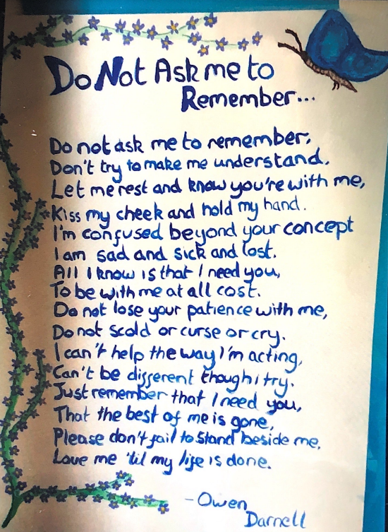

Top tips for…..

Living with Dementia? What do you want people without Dementia to know or do?
To try to understand, REALLY understand
Keep calm, don't shout at me!
Be kind and forgiving, I don't mean to be difficult
To Try to TREALLY understand
T
To Try to TREALLY understand
T
To Try to TREALLY understand
T
To Try to TREALLY understand
T
don’t say "I told you so" I can't always remember what I have said

